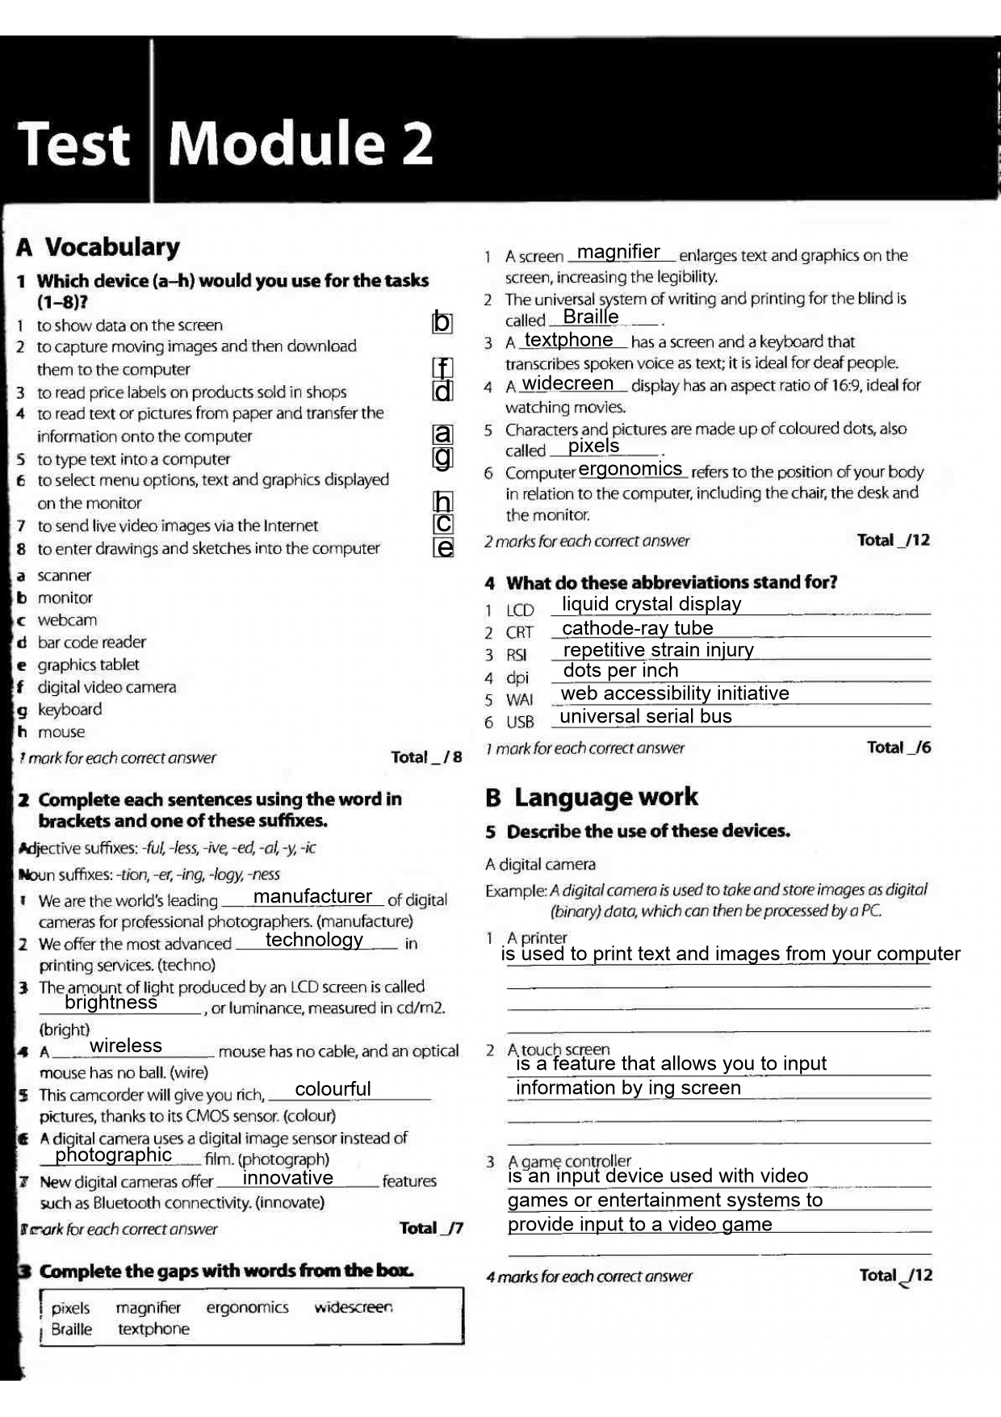

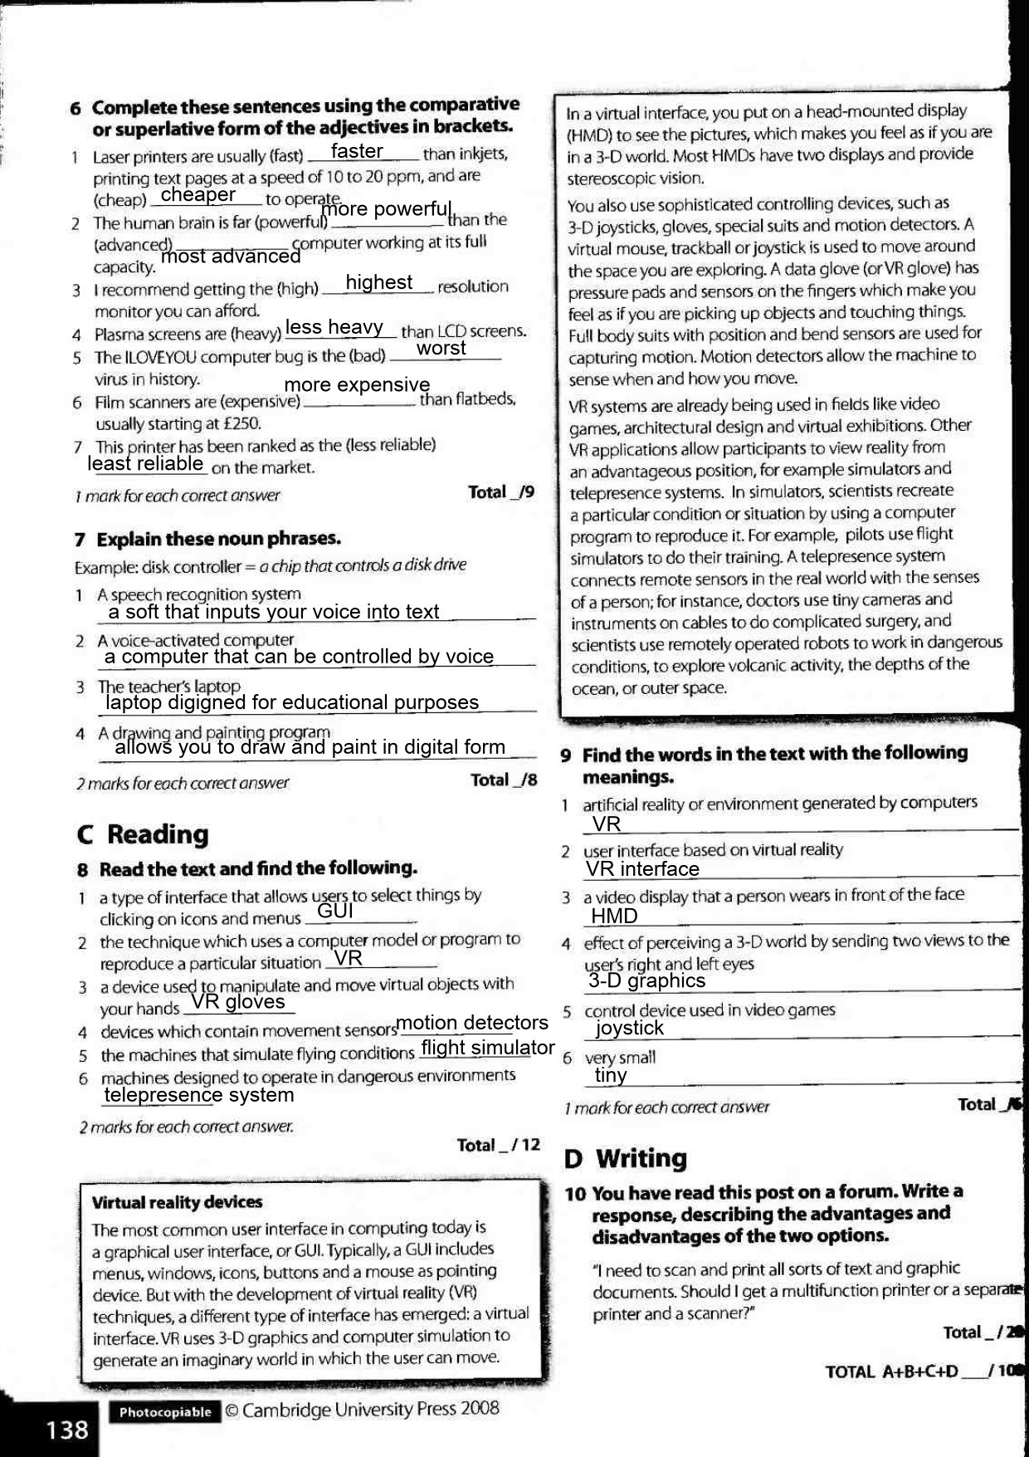

A multifunctional printer is extremely useful if you have little space at home or in the office. Also, buying a multifunction printer will cost you less than a printer and a scanner separately. But a multifunction printer will provide you with worse quality than a separate printer and scanner. In addition, when using separate devices, you can print something on the printer and use a scanner at the same time, on a multifunction printer you will not be able to print and scan at the same time. Also, often, if one of the parts of a multifunctional printer is broken, it will fail completely, and you will lose the ability to use the rest of its functions. If constant and simultaneous scanning with printing is required, I recommend buying both a printer and a scanner, otherwise buy a multifunctional printer.